## Exam assignments:



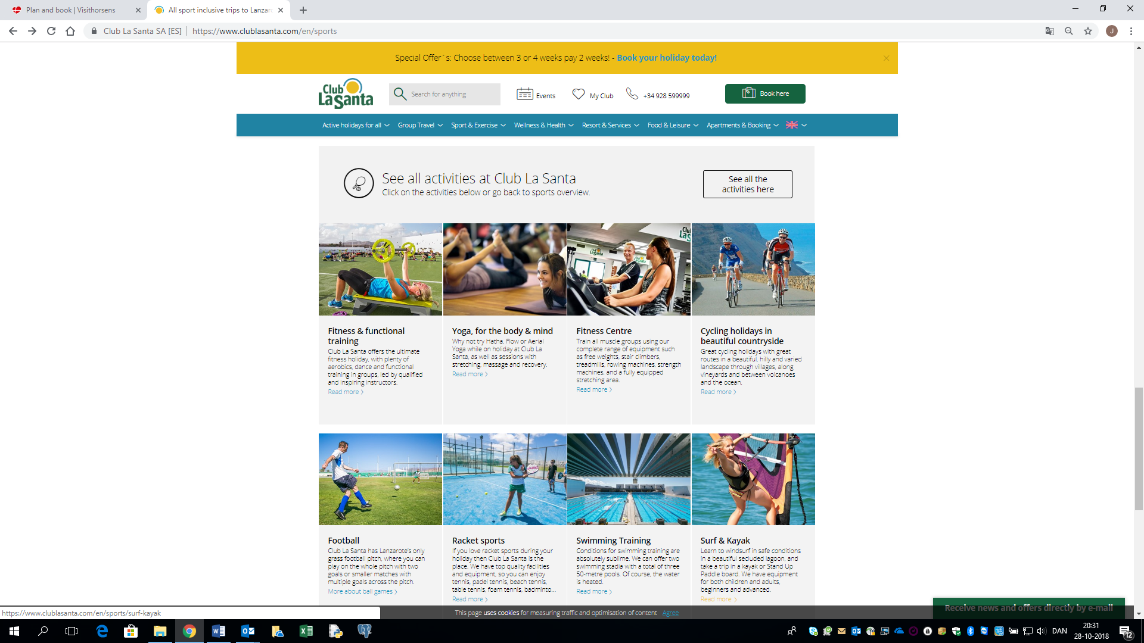

Inspiration for this project work: <https://www.clublasanta.com/en>

* Subject 1: Create a database for booking bikes for cycling in the beautiful landscape.
* Subject 2: Create a database for booking time for fitness & functional training.
* Subject 3: Create a database for booking time for yoga, for the body and mind.
* Subject 4: Create a database for booking time in the fitness centre.
* Subject 5: Create a database for booking time in swimming training centre.
* Subject 6: Create a database for booking time for surfing.
* Subject 7: Create a database for booking time for kayaking.
* Subject 8: Create a database for booking time for ballroom dancing.
* Subject 9: Create a database for booking time for beach tennis.
* Subject 10: Create a database for booking conference rooms.
* Subject 11: Create a database for booking time for airport transfers.
* Subject 12: Create a database for booking time for diving.
* Subject 13: Create a database for booking time for snorkelling.
* Subject 14: Create a database for booking time for athletics.
* Subject 15: Create a database for booking time for bouldering.
* Subject 16 Create a database for booking time for cross fit.

Sport

## Requirements for the exam project – it would be updated:

Hand in 1:

* Analyse and design for the exam project.
  + ER-diagram and/or relational diagram.
    - Max 5 entities/tables.
  + GUI design
  + Description
* Max 2 pages.
* Creating ABAP Tables
  + Domain
  + Data-element
  + Tables
  + Currency Field
  + Quantity Field
  + Views
  + Transaction code
  + Search Help
* Only 3 tables with referential integrity.
* Procedural programming i ABAP
  + Data types and data objects
  + Operations and expression
  + Control Structures
  + Processing Character Strings
  + Internal tables.
  + Modularization
    - Functions modules
    - Subroutines
    - Include reports
* GUI and reports
  + Screens – GUI in Flow Logic
  + Selection screen
  + Lists
  + Message
  + ALV list
* Export and import of data
  + File interface
* Hand in: 14 Of October.

Hand in 2:

Requirements is coming – but it will be a project in the Area of SAP.

/jca

